Josef Gonzalez
Professor Holden-Gouveia
Linux Administration
Server Set Up Lab
October 11, 2026
This guide explains how to set up CentOS Stream 10 and Ubuntu Server in Oracle VirtualBox, connect the two servers on a host-only network, and transfer a file between them using SSH and SCP. The setup was completed on a Mac with an M3 processor, so ARM64 installation images were used.

1. Install CentOS Stream 10
Download the ARM64 version of CentOS Stream 10 and create a new virtual machine in VirtualBox. For this setup, assign 4 GB of RAM, 2 processors, and a 25 GB virtual hard drive. Start the VM with the CentOS installation image attached.
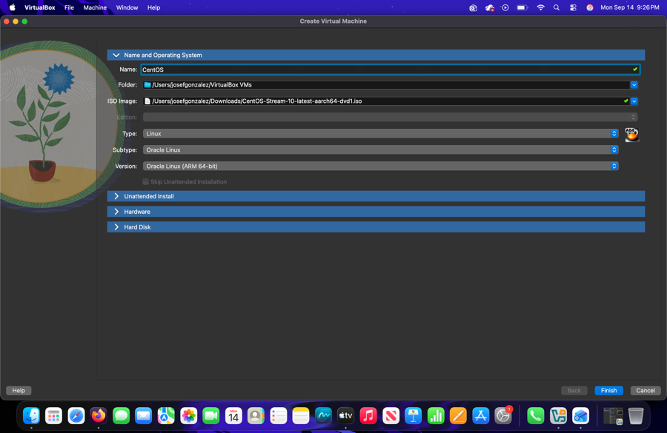
CentOS installation
During installation, select the Server environment instead of a desktop GUI. Complete the storage, account, and network settings, then install CentOS. Restart the virtual machine and sign in at the terminal.
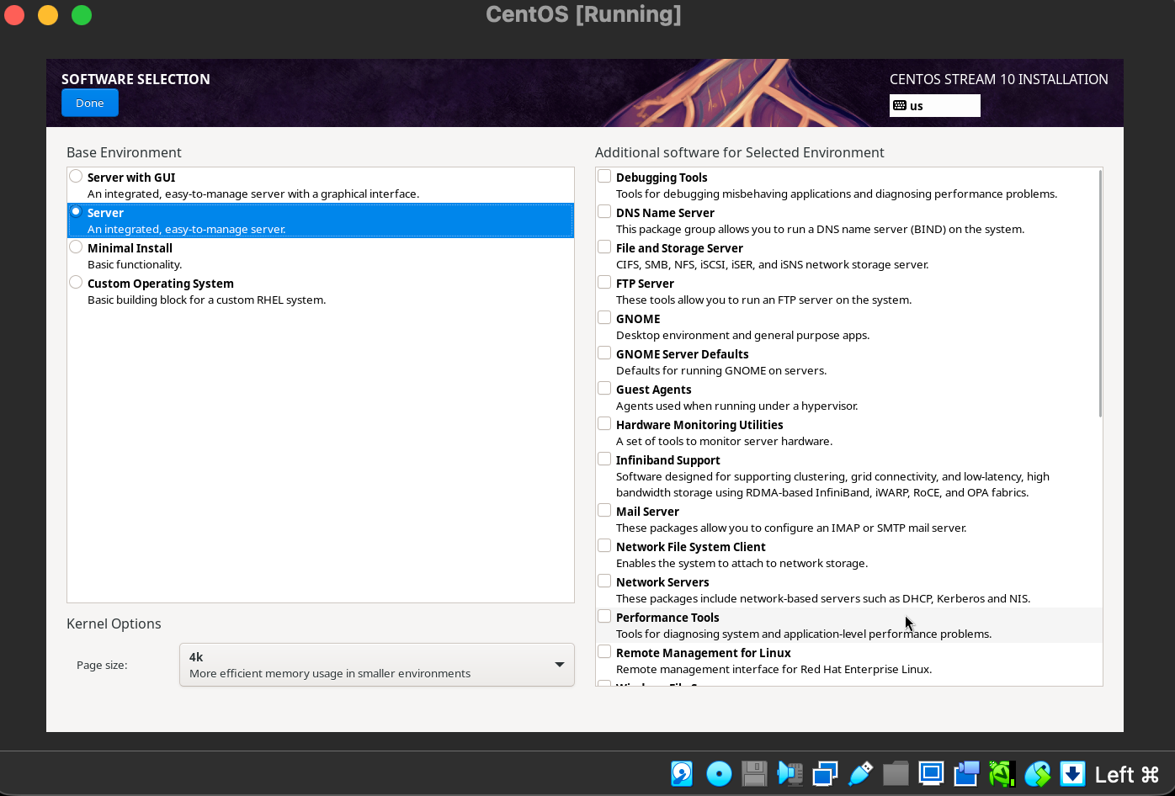
Network configuration

2. Check the CentOS Network
Leave Adapter 1 connected to NAT so the server can access the internet. The default network gave CentOS an address of 10.0.2.15/24. After signing in, test internet access with this command:
ping -c 4 google.com
Four replies with 0% packet loss indicate that the network is working.

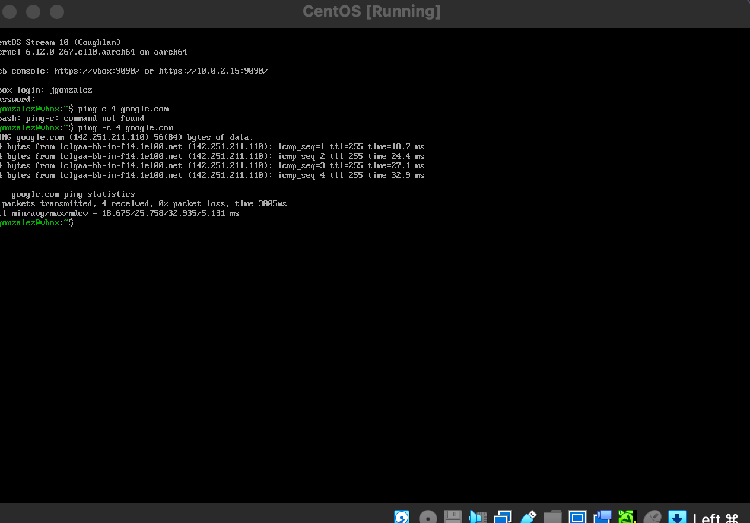
Pinging to see if I am connected to internet

3. Install Ubuntu Server
Create a second VirtualBox virtual machine named Ubuntu Server. Use the Ubuntu Server ARM64 installation image and a 25 GB virtual hard disk. In the installer, accept the detected network settings, leave the proxy field empty, use the default Ubuntu package mirror, and select the guided storage layout. The guided storage option applies only to the Ubuntu VM virtual disk.
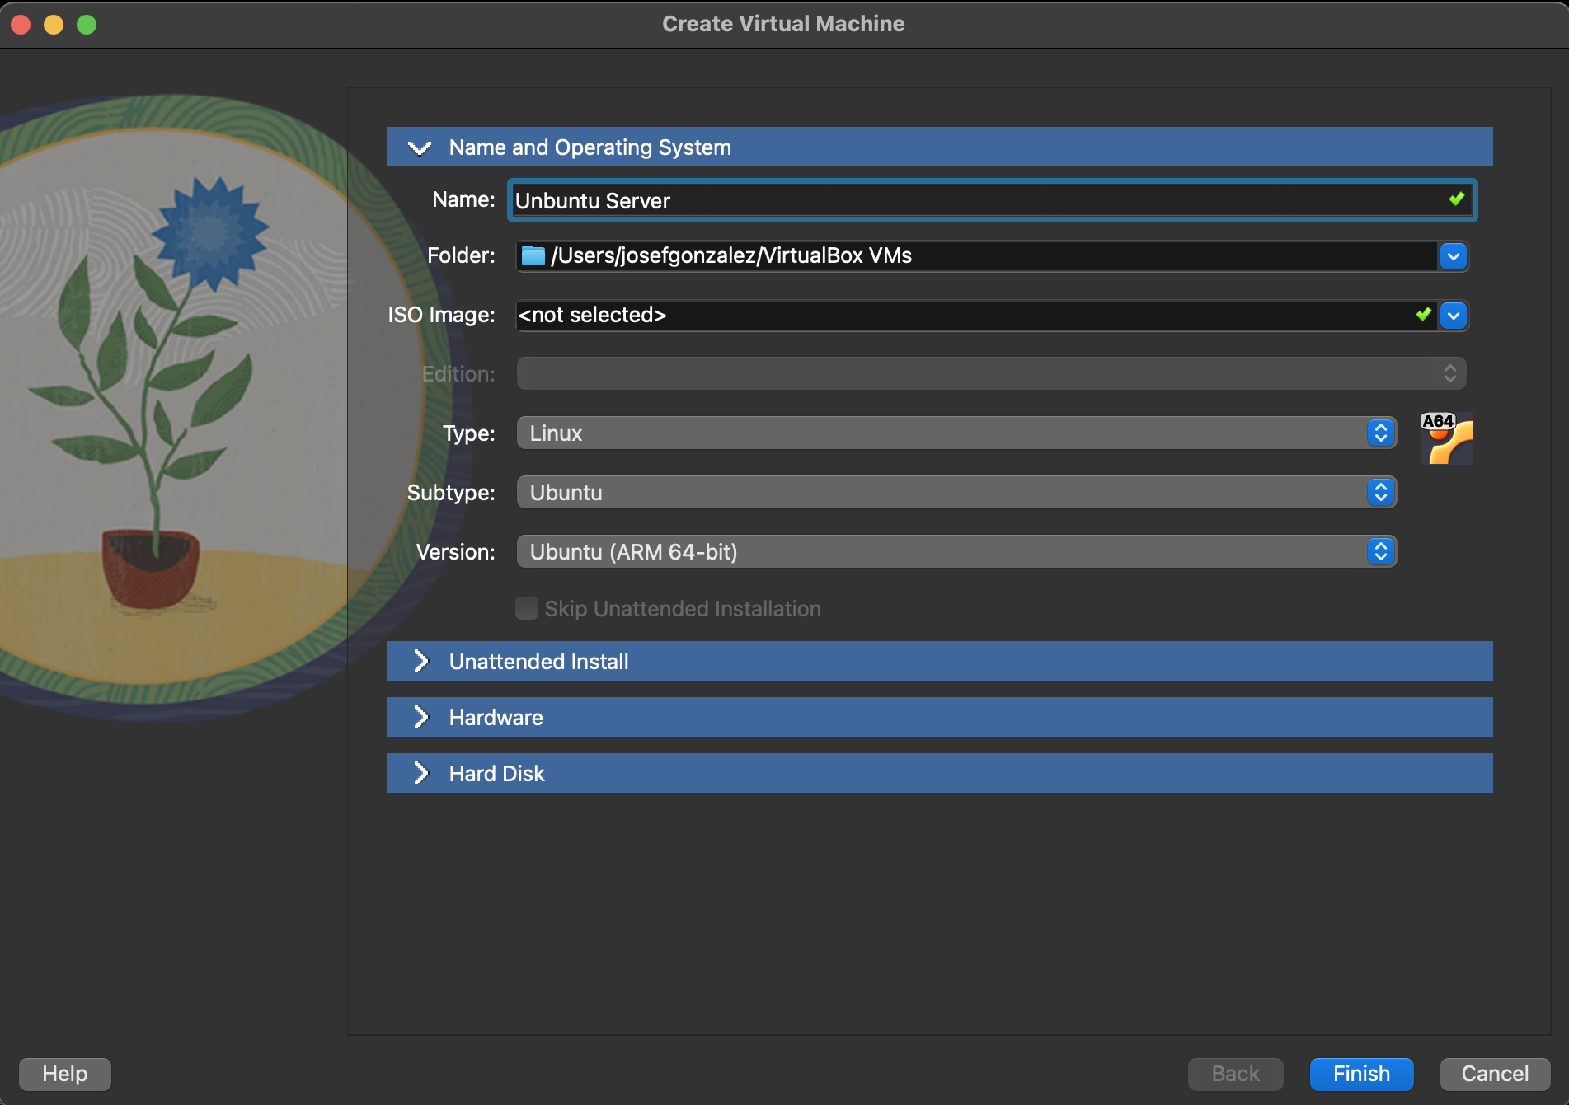
Unbuntu server installation
Create a server name, username, and password. Skip Ubuntu Pro for this lab, and select Install OpenSSH server so the machine can accept remote connections. Finish installation, remove the installation ISO if prompted, reboot, and log in.
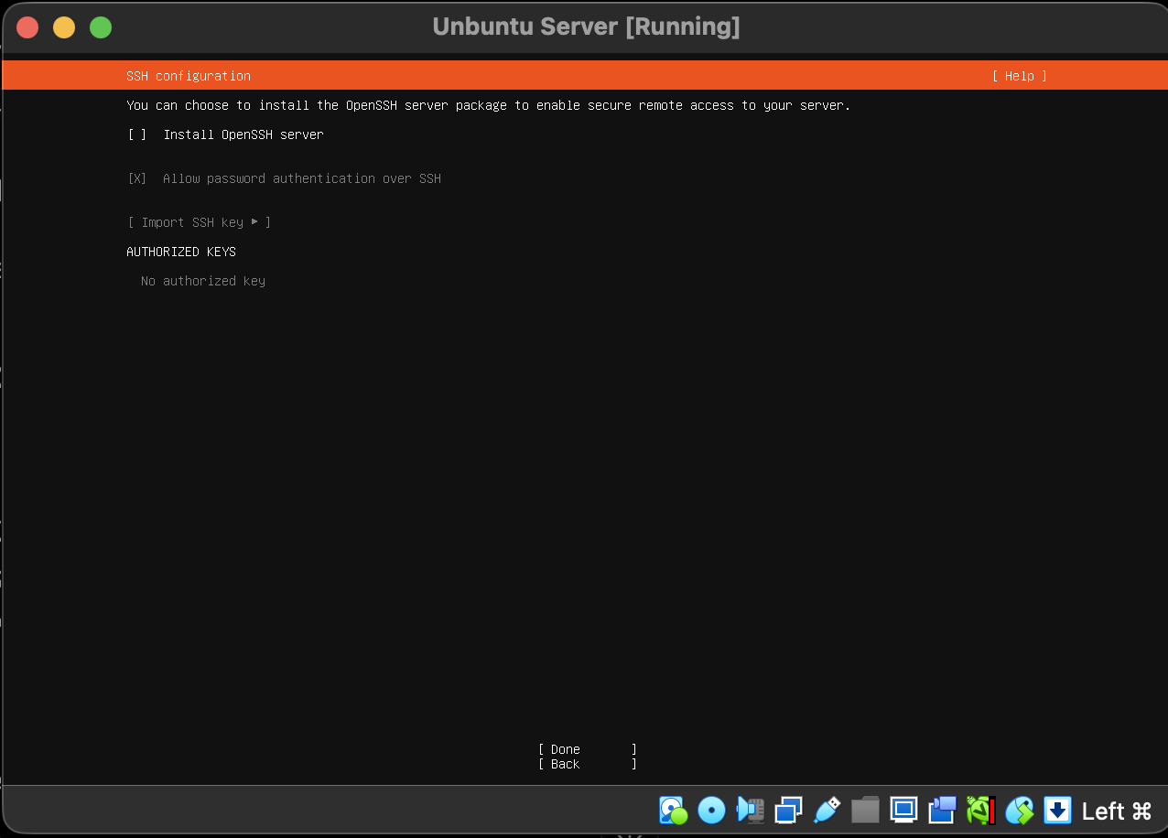
Enable the Openssh server this is very important

4. Connect Both Virtual Machines to a Host-Only Network
Shut down both VMs before editing their VirtualBox settings. In the VirtualBox Manager, create a host-only network named HostNetwork. The network in this lab used the 192.168.56.0/24 subnet. For each VM, leave Adapter 1 set to NAT and enable Adapter 2 as Host-only Network with the name HostNetwork. Keep Cable Connected checked. Then start both servers.
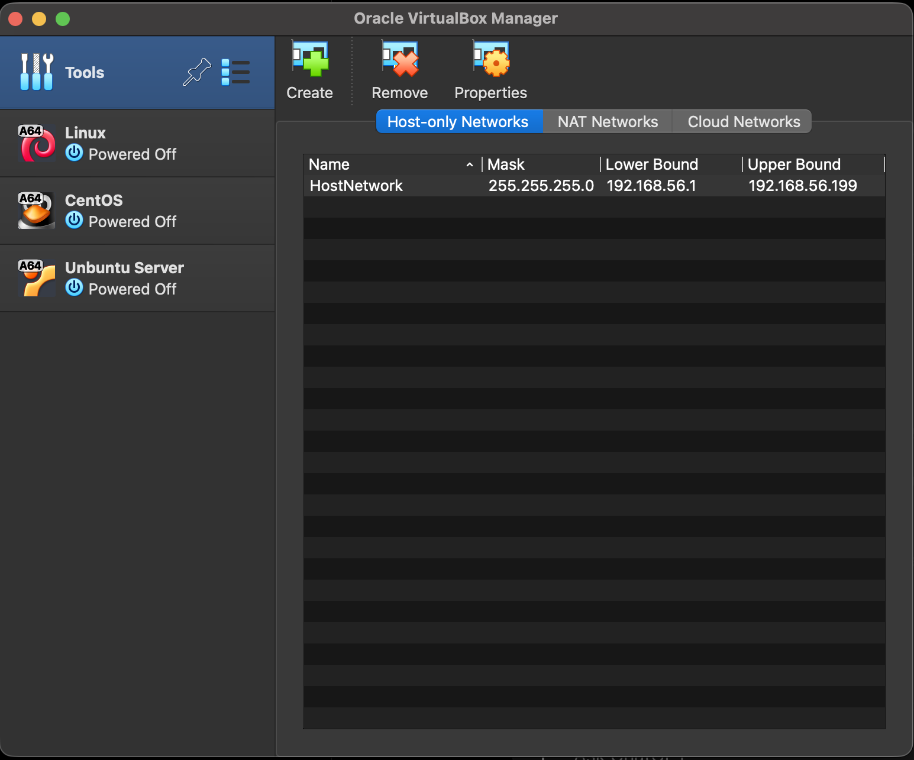
Creating the host server
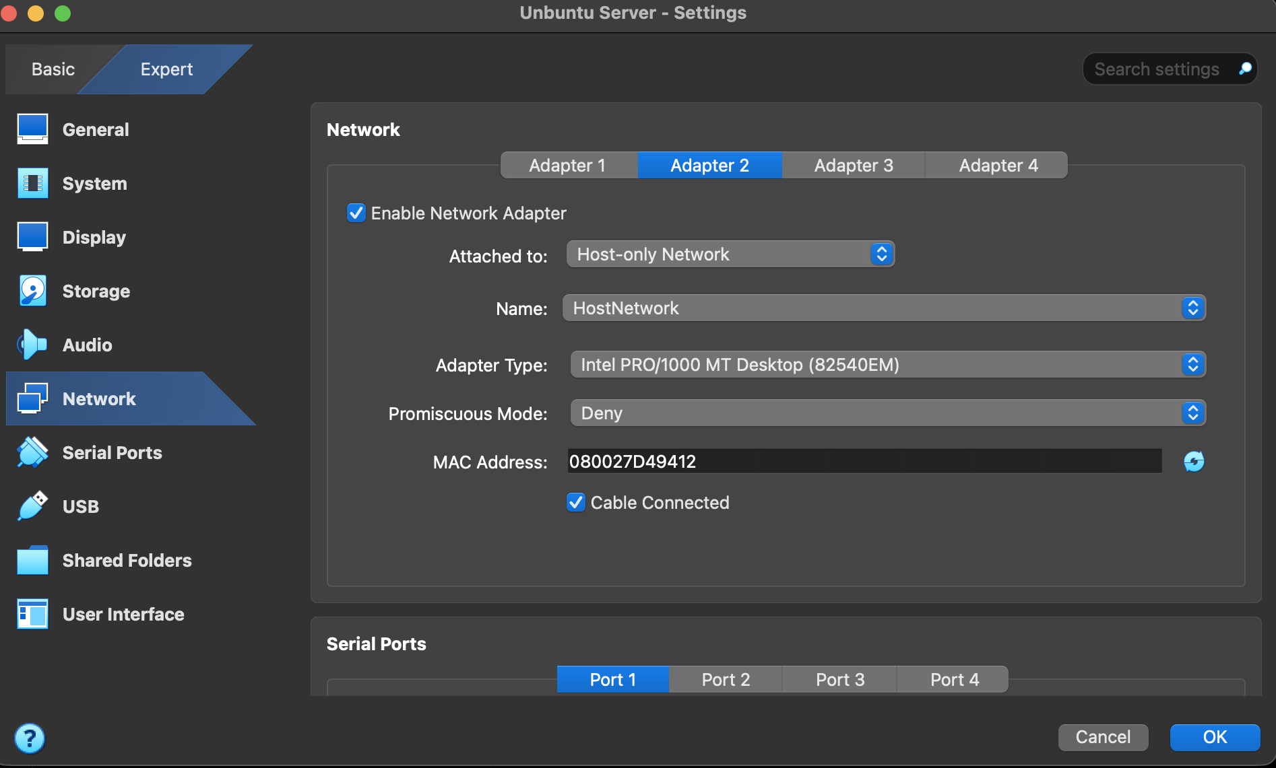
Making sure we are on adapter 2 with these options
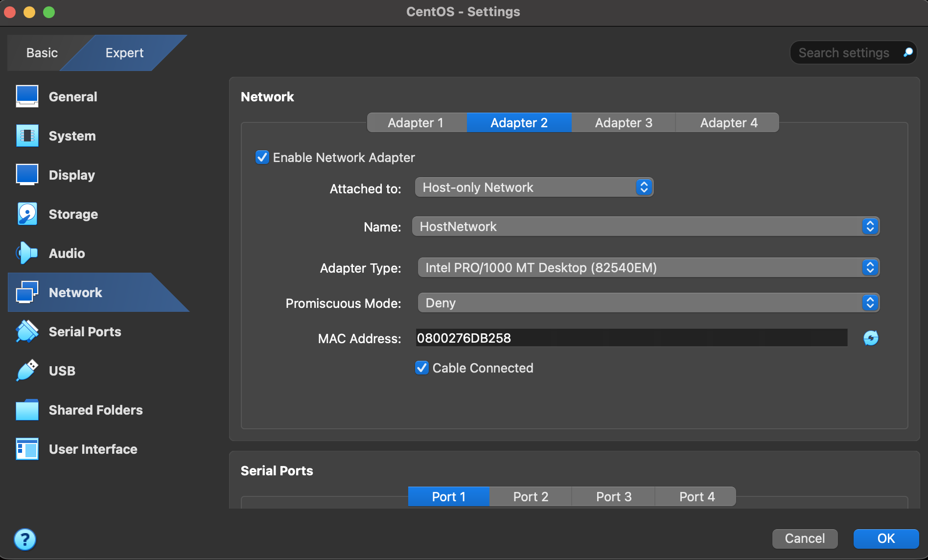
Same as unbuntu adapter

5. Find the IP Addresses and Test Communication
On both servers, run the following command to view the IPv4 addresses:
ip -4 addr
The host-only adapter is separate from the NAT adapter. In this lab, CentOS received 192.168.56.3 and Ubuntu received 192.168.56.2. The NAT adapter on each VM may also show 10.0.2.15, but that is not the address used for communication between the two servers.
From Ubuntu, ping CentOS:
ping -c 4 192.168.56.3
From CentOS, ping Ubuntu:
ping -c 4 192.168.56.2
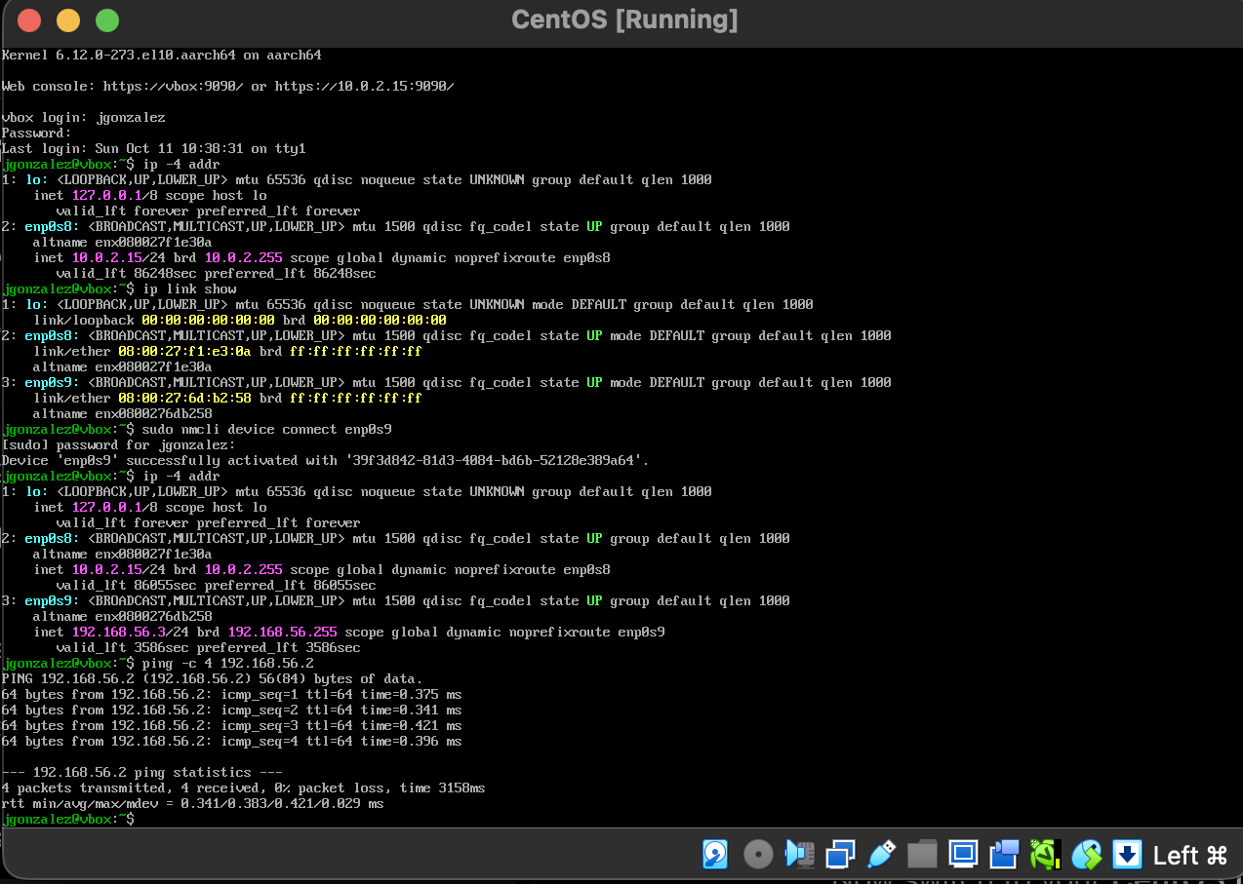
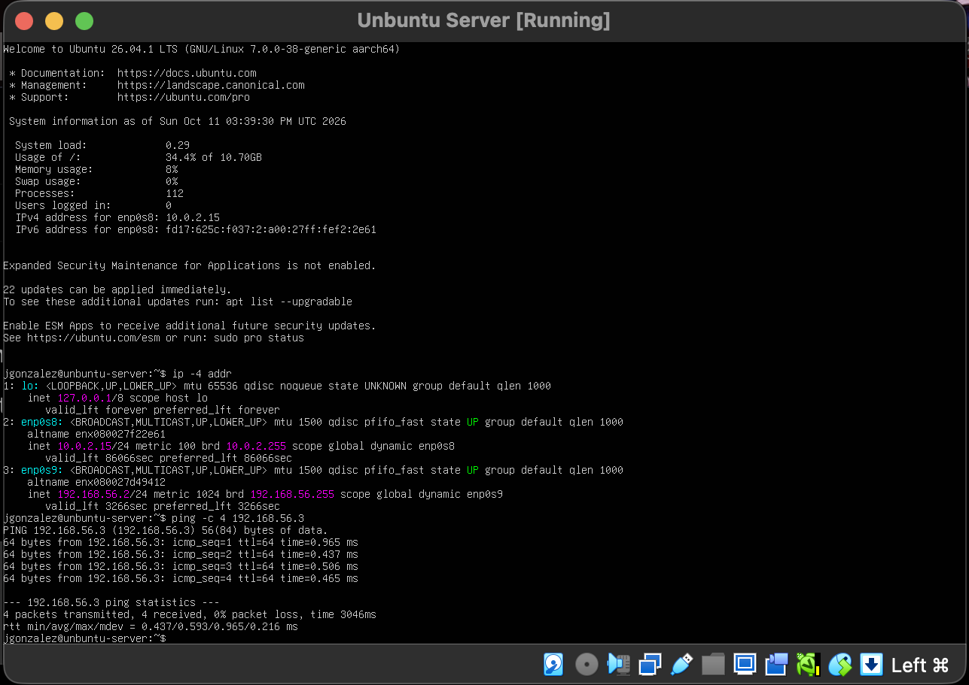
Pinging to make sure that both Vms can reach each other with no packet loss
Both tests returned four replies with 0% packet loss, confirming that the two VMs could reach each other.

6. Connect from CentOS to Ubuntu Using SSH
OpenSSH was enabled on Ubuntu during installation. From the CentOS terminal, use SSH to connect to the Ubuntu account. Replace the username if your account is different:
ssh jgonzalez@192.168.56.2
The first connection may ask whether to trust the host key. Type yes, then enter the Ubuntu account password. When the Ubuntu welcome message appears, the remote login has worked. To return to CentOS, type:
Exit

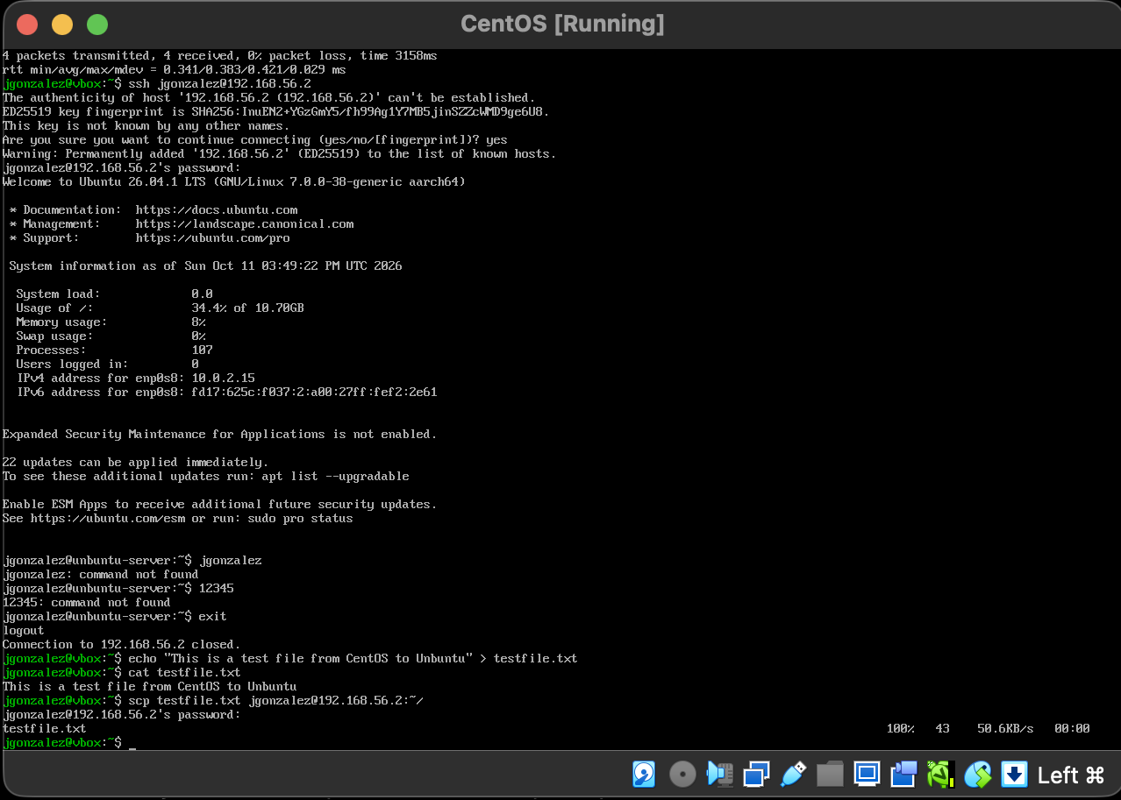
Showing that I connected via ssh to my Unbuntu server

7. Transfer a File with SCP
In the CentOS terminal, create a small text file and display its contents:
echo "This is a test file from CentOS to Ubuntu" > testfile.txt
cat testfile.txt
Use SCP to copy that file to the Ubuntu home directory. Enter the Ubuntu password when prompted:
scp testfile.txt jgonzalez@192.168.56.2:~/
The terminal showed testfile.txt transferred at 100%, which indicates the copy completed.

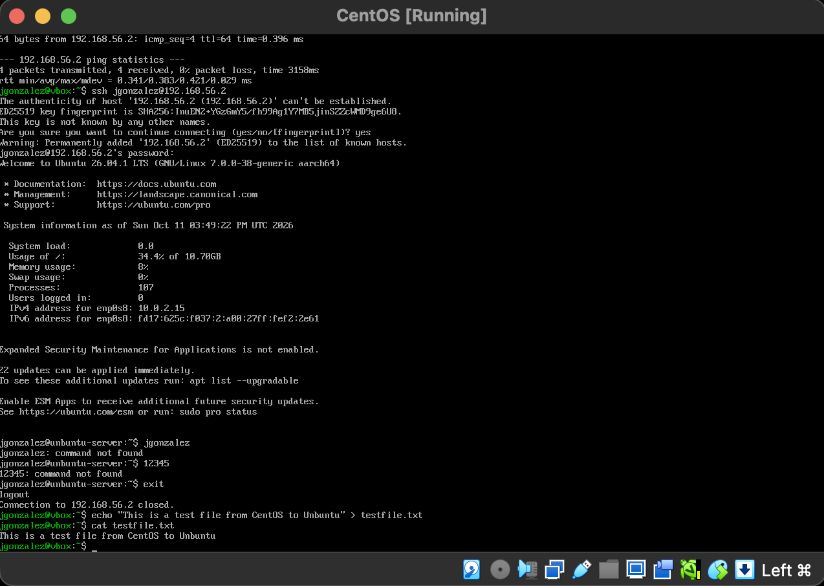
Created a quick file that I could send to other server
Finally, switch to the Ubuntu terminal and verify the file is present and contains the correct text:
ls -l ~/testfile.txt
cat ~/testfile.txt
Ubuntu displayed “This is a test file from CentOS to Ubuntu,” confirming the file was transferred and could be opened.
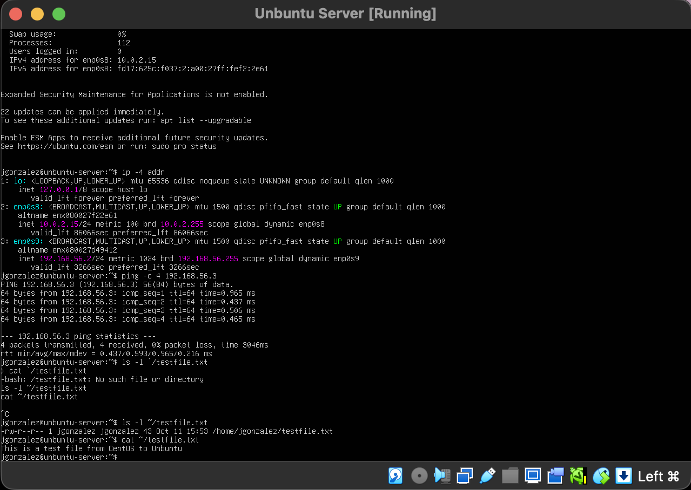
Verifying that my server received the test file which it did

Conclusion
Both CentOS Stream 10 and Ubuntu Server were installed in separate VirtualBox virtual machines. NAT provided internet access, and a shared host-only network allowed the servers to communicate. After verifying the connection with ping, I connected to Ubuntu from CentOS using SSH and copied a test file using SCP. The file was then opened on Ubuntu to confirm the transfer worked.

